**THE OXFORD SENIOR SECONDARY SCHOOL  
(AFFILIATED TO C.B.S.E., NEW DELHI)  
I PHASE, J.P. NAGAR, BENGALURU-78**

CLASS XII-PHYSICS WORKSHEET-6

ELECTROMAGNETIC INDUCTION

Multiple choice questions:

1. In the expression e = –d∅/dt, the negative sign signifies:

(a) The induced emf is produced only when magnetic flux decreases

(b) The induced emf opposes the change in the magnetic flux

(c) The induced emf is opposite to the direction of the flux

(d) None of these

2. 1 henry is equal to:

(a) weber/ampere

(b) weber/Volt

(c) weber ampere

(d) None of these

3. The role of inductance is equivalent to:

(a) inertia (b) force (c) energy (d) momentum

4. A choke is used as a resistance in:

(a) dc circuits (b) ac circuits

(c) both ac and dc circuits (d) neither (a) nor (b)

5. In the relation φ = B A cos θ, θ is angle

(a) which normal to the surface area makes with the direction of magnetic field.

(b) which magnetic field makes with the surface.

(c) is always a constant.

(d) None of the above.

6. SI unit of magnetic flux is

(a) Henry (b) weber (c) coulomb (d) volt

7. An induced e.m.f. is produced when a magnet is plunged into a coil. The strength of the induced e.m.f. is independent of

(a) the strength of the magnet (b) number of turns of coil

(c) the resistivity of the wire of the coil (d) speed with which the magnet is moved

8. According to Faraday’s law of electromagnetic induction

(a) electric field is produced by time varying magnetic flux.

(b) magnetic field is produced by time varying electric flux.

(c) magnetic field is associated with a moving charge.

(d) None of these

9. A moving conductor coil produces an induced e.m.f. This is in accordance with

(a) Lenz’s law (b) Faraday’s law

(c) Coulomb’s law (d) Ampere’s law

10. The polarity of induced emf is given by

(a) Ampere’s circuital law (b) Biot -Savart law

(c) Lenz’s law (d) Fleming’s right-hand rule

11. The self-inductance of a coil is a measure of

(a) electrical inertia (b) electrical friction

(c) induced e.m.f. (d) induced current

12. The coils in resistance boxes are made from doubled insulated wire to nullify the effect of

(a) heating (b) magnetism (c) pressure (d) self-induced e.m.f.

13. The current flows from A to B is as shown in the figure. The direction of the induced current in the loop is

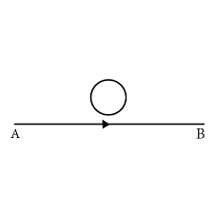

(a) clockwise. (b) anticlockwise.

(c) straight line. (d) no induced e.m.f produced.

14. There are two coils A and B as shown in figure. A current start flowing in B as shown, when A is moved towards B and stops. B is kept stationary when A moves. we can infer that

(a) there is a constant current in the clockwise direction in A.

(b) there is a varying current in A.

(c) there is no current in A.

(d) there is a constant current in the counter clockwise direction in A.

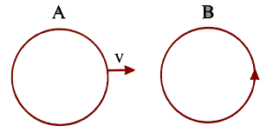

15. (i) Show that Lenz’s law is in accordance with the law of conservation of energy. (ii) Two bar magnets are quickly moved towards a metallic loop connected across a capacitor ‘C’ as shown in the figure. Predict the polarity of the capacitor.



